**Cloud Networking & Load Balancer Setup**

**Networking Basics**

**What is cloud networking?**

Cloud networking refers to the practice of connecting and managing computer resources in the cloud over the internet. It enables secure communication between cloud-based servers, applications, and users. Unlike traditional networks, cloud networking abstracts the underlying hardware, allowing resources to be scaled, managed, and monitored efficiently. Cloud networking is essential for deploying applications globally, ensuring availability, security, and optimized performance.

**Key Concepts**

**1. Virtual Private Cloud (VPC)**

A VPC is a virtual network dedicated to a user’s cloud environment. It provides isolation from other users’ networks and allows control over IP addresses, subnets, routing, and network gateways.

* Example: AWS VPC or Azure Virtual Network.
* Purpose: Create a secure and private environment in the cloud**.**

**2. Subnet**

A subnet is a subdivision of a VPC that allows you to organize and segment resources. Subnets can be public (accessible from the internet) or private (internal-only access).

* Purpose: Improve security and manage network traffic efficiently**.**

**3. Security Groups**

Security Groups are virtual firewalls that control inbound and outbound traffic for cloud resources, such as EC2 instances.

* Rules can allow or block specific ports, protocols, and IP addresses.
* Example: Allow HTTP (port 80) and SSH (port 22) while blocking all other traffic.

**4. Load Balancers**

Load Balancers distribute incoming traffic across multiple cloud instances to ensure high availability and performance.

* Types: Application Load Balancer (ALB), Network Load Balancer (NLB).
* Benefits: Prevent single points of failure, handle more traffic, and improve user experience.

**Why scaling with multiple instances is important.**

Scaling with multiple instances ensures that applications can handle increased traffic without downtime. If one server fails, others can take over, providing **fault tolerance** and **reliability**. Cloud networking allows horizontal scaling (adding more servers) and vertical scaling (increasing resources on existing servers), making applications resilient, responsive, and capable of serving users globally.

**A diagram of a Load Balancer distributing traffic to multiple servers**

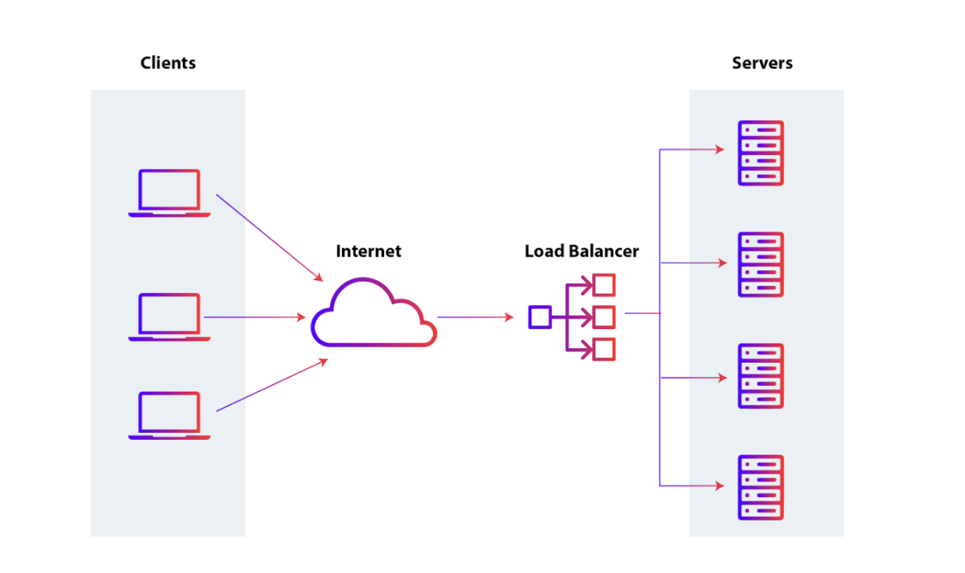

**“Prepared during Internship at Edoras”**

**Reflection / Understanding**

**What I understood about cloud networking and load balancers.**

I learned that cloud networking involves connecting multiple resources like servers, databases, and applications within a cloud environment securely and efficiently. Virtual Private Clouds (VPCs) help isolate networks, while Security Groups act as virtual firewalls controlling inbound and outbound traffic. Load balancers distribute incoming traffic across multiple servers to ensure high availability, better performance, and fault tolerance.

**Challenges you faced.**

One challenge was configuring the security rules correctly to allow traffic while keeping the system secure. Another was setting up the load balancer to route traffic evenly between multiple servers without downtime.

**How I solved them.**

I carefully followed the documentation to understand VPC and Security Group configurations, tested connectivity step by step, and used health checks on the load balancer to monitor server status. By testing and troubleshooting incrementally, I was able to achieve a stable and scalable cloud setup.